New book to bless those whom have blessed you countless times!

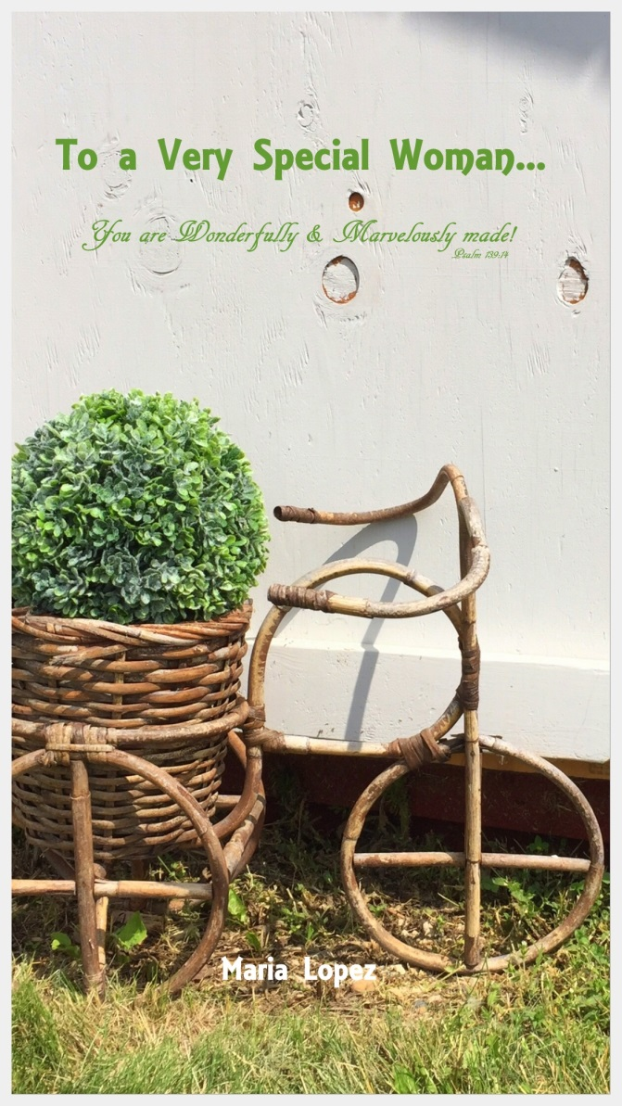
‘To a Very Special Woman’ is a book to say Thank You to the special women in your life. It’s blessing those who have blessed you countless times with their strength, faith, and words of encouragement to help get you through difficult times in your life and who have also shared in your joys. In this book I share encouragement through various prayers and promises found in the Bible. Every prayer and promise is interwoven with beautiful and original photography that I have been able to capture in nature to visibly see and share an All-loving and All-powerful God through His hand of creation.

“The generous soul will be made rich, and they who water will also be watered themselves.”
Proverbs 11:25

May this book comfort, and water you, as you have watered so many. Thank you for sharing the gift of your life!

Your Copy only $15! **48 pages of promises and encouragement interwoven with original photography to inspire and bless the one receiving.

